DB Script

Burn-Downchart

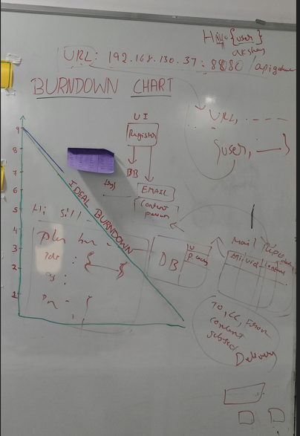

Product Backlog

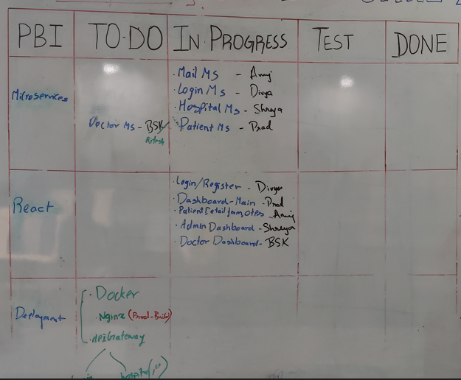

User Stories

